W-20

**YEAR 12 PHYSICS**

**ASSIGNMENT 4 - ELECTROMAGNETISM**

Name: Mark:

1. A wire carrying a current of 1.68 A has 8.75 × 10-2 m of its length passed through a

4.44 × 10-2 T magnetic field at right angles to it as shown below. The circuit is part of an apparatus that is able to measure the torque produced by the current passing through the magnetic field.

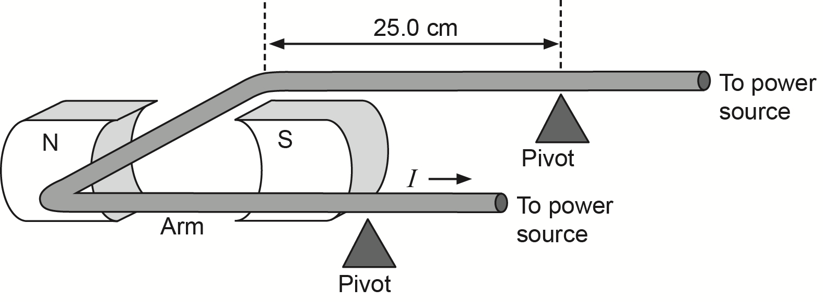page9image48489552

Given that the arm has a length of 25.0 cm from the wire in the field to the pivot point, calculate the torque produced. Include direction with your answer. (4 marks)

Answer Nm

Direction

2. (a) Draw an arrow indicating the direction of the magnetic field at point P due to the magnet shown. (2 marks)



(b) Describe the effect on a positively-charged particle travelling into the page at P.

(2 marks)

3. (a)   Draw an arrow indicating the direction of the magnetic field at point P due to the current-carrying wire Q as shown. (2 marks)



(b)   Describe the effect on a positively-charged particle travelling into the page at P due to the current-carrying wire. (2 marks)

4. The magnetic constant *μ*0 is the magnetic permeability of a vacuum. An iron alloy would have a different permeability *μ*a. To determine its permeability, a large block of the iron alloy had an insulated current-carrying wire pass through its middle. A measure of the magnetic field strength 1.00 m from the wire was made as the current was varied as shown on the graph below.

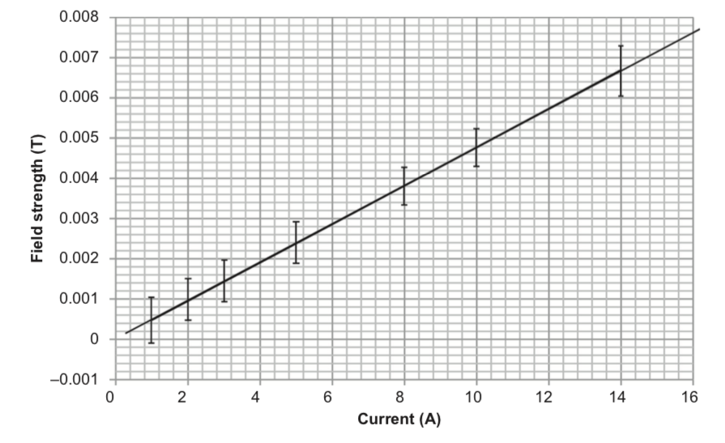 Use $B = \frac{μI}{2πr}$ to determine a gradient for the graph above and hence the magnetic constant *μ* (where *μ* = *μ*0 *μ*a). (3 marks)

*μ* = (no units required)

(b) Use the gradient and the vertical error bars in the graph on page 14 to comment on the uncertainty of your answer to part (a). Express your answer in the appropriate significant figures. (4 marks)

Answer ± (no units required)

5. Two identical, electrically-charged spherical balls tied to the ends of cords of negligible mass revolve freely in a horizontal plane as shown in the diagram below. The electric charge on each ball is 7.00 × 10-6 C. The radius of the circle of motion is 1.10 m. The period (*T*) of revolution is 2.50 s and the mass of each ball is 0.200 kg. (Ignore the interference by any magnetic field interaction, including Earth’s magnetic field.)

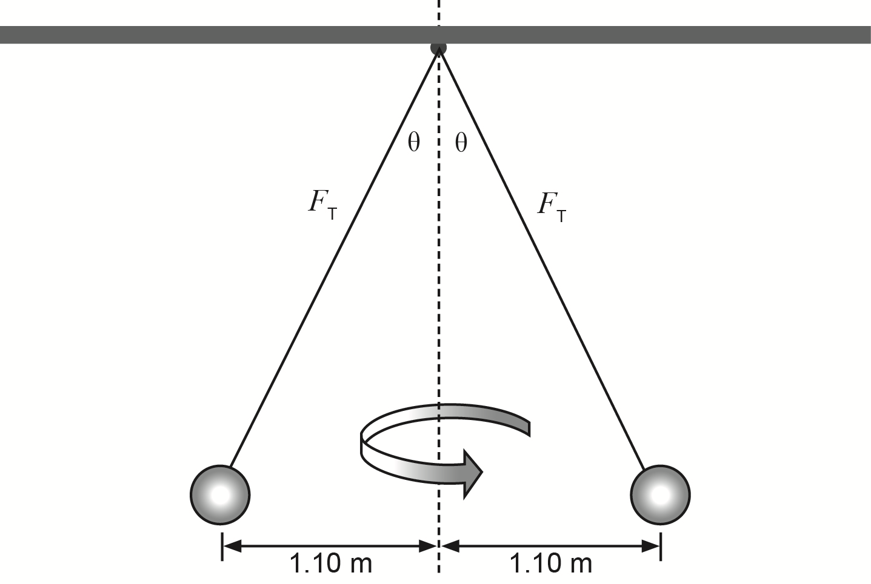

(a) On the ball below, complete a labelled, free body diagram of the force(s) acting on one of the balls. (3 marks)

page32image49189360

(b) Show by calculation that the magnitude of the velocity of each ball is 2.76 ms-1.

(1 mark)

(c) Determine the angle (θ) and the tension (*F*T) of one of the cords. (6 marks)

Answer N at an angle of

(d) In completing the calculations for part (c), why it is reasonable to consider the gravitational attraction between the two spheres to be negligible? Use a formula to support your answer. (3 marks)

6. An experiment was conducted to determine the effect of an external magnetic field on a current-carrying conductor. A DC solenoid was used to produce a constant magnetic field of 32.0 μT. A conductor carrying a direct current of 285 mA was introduced to the magnetic field. The conductor was fixed in place and carries the current directly into the page. Point A is 8.00 mm from the centre of the conductor, along a line parallel to the constant magnetic field as shown below.

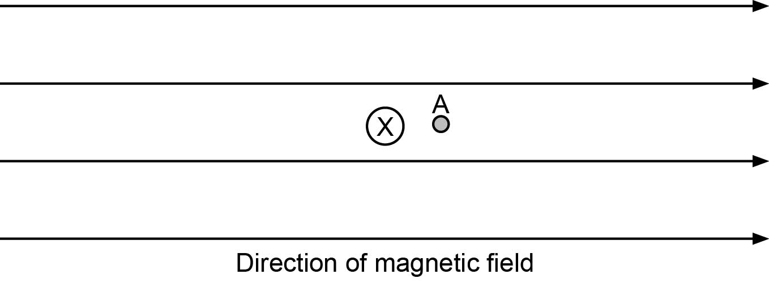

(a) Use the information above to calculate:

(i)   the magnitude of the magnetic field at point A due to the current in the conductor.

(2 marks)

Answer magnitude T

(ii)   the magnitude and direction of the resultant magnetic field at point A. If you were unable to obtain an answer to part (a) (i), use 6.00 × 10-6 T. Include a diagram in your answer. (3 marks)

Answer magnitude T

Direction

(b) Sketch the resultant magnetic field around the conductor. (2 marks)

7.A pith ball is a very small, lightweight object that readily picks up electric charge. A pith ball with a mass of 75.0 × 10−6 kg is suspended by a string attached to a charged plate. The pith ball has an excess of 2.00 × 1012 electrons on it and the electric field strength between the charged plates is 95.0 NC−1.

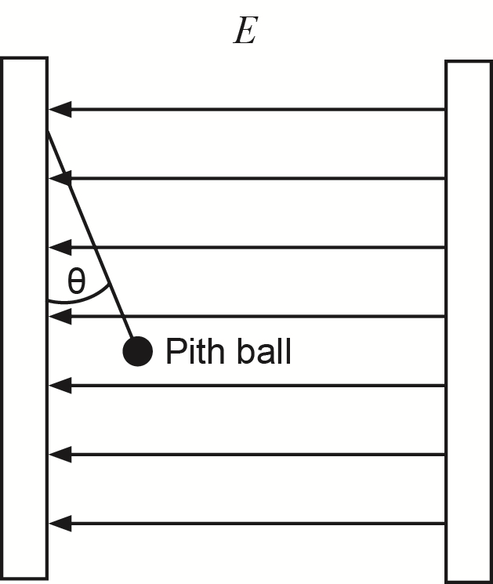

(side view)

(a) In the space below, draw a vector diagram of the forces acting on the pith ball.

(3 marks)

(b) Calculate the angle between the string and the charged plate. (5 marks)